*New* 2016-2021 Camaro LT/LS/SS/ZL1 Single 10/12 Front Fire Subwoofer Box
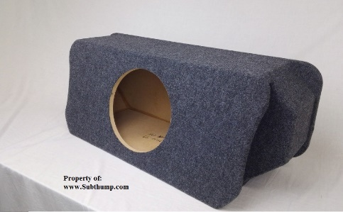
$220
American Bass XR-12
$215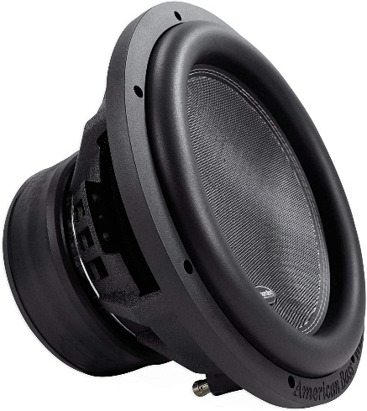
Kicker 46KISLOC2 K-Series Stereo Line-Output Converter w/Remote Turn-On Output
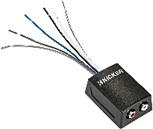
$27
Audiopipe APMN-2000 RMS Class D Monoblock Subwoofer Amplifier, 2000W Mono Sub Amp
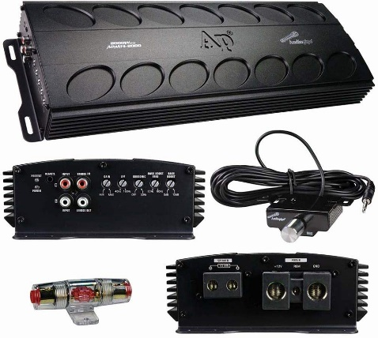 Volume: 1.5 cu.ft (sealed)
$228
Skar Audio 1/0 Gauge OFC Complete Amplifier Installation Wiring Kit
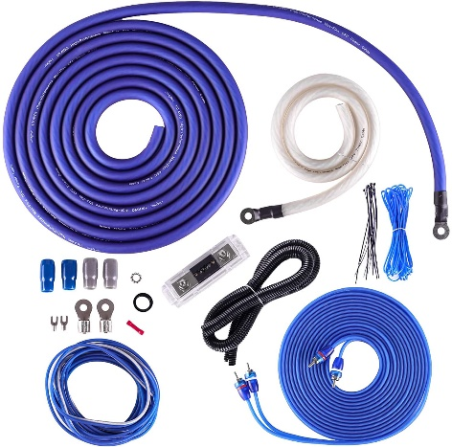
$93
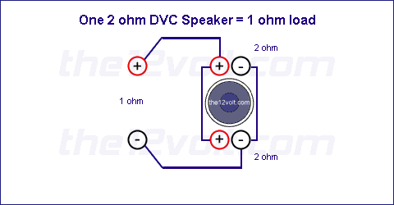
12v Fuse tap Fuse 33 or 55
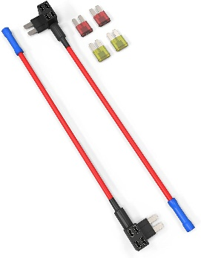
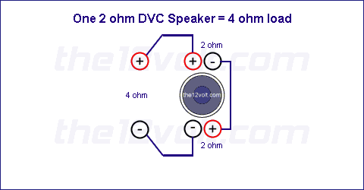
$10
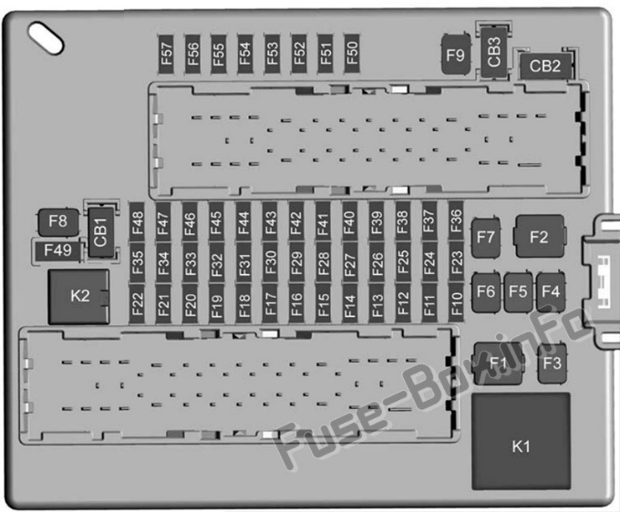
TOTAL: $793 before shipping
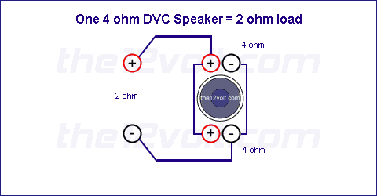

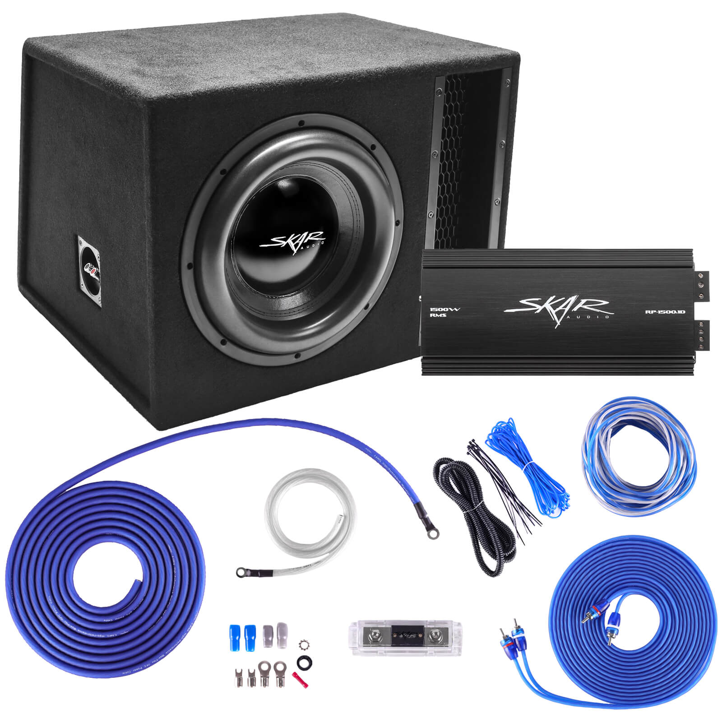
Single 12" 2,500 Watt EVL Series Complete Subwoofer Package with Vented Enclosure and Amplifier

TOTAL $570

