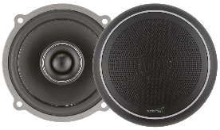
Audiofrog GS42: 4-inch 2-Way Coaxial Speaker System

JL Audio XD1000/5v2
Main Channels - Bridged @ 4Ω = 200 W RMS x 2
Main Channels @ 4 Ω = 75 W RMS x 4
Main Channels @ 2 Ω = 100 W RMS x 4
Subwoofer Channel @ 2 Ω = 600 W RMS x 1
MS-8 CHANNEL 5 (FRONT CENTER)
Continuous Power Handling (RMS) | 50 W
Peak Music Power | 150 W
Recommended Amplifier Power (RMS) | 15 - 75 W
System Efficiency | 88 dB @ 2.83 V/1 M
System Nominal Impedance | 4 Ω
System Frequency Response | 90 Hz - 20 kHz
AMP - CHANNEL 1

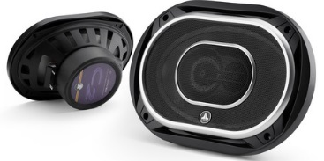
MS-8 CHANNEL 6 (REAR DECK = LR)
MS-8
CHANNEL 5

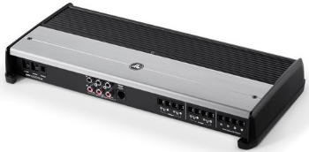
JL Audio C2-690tx: 6 x 9-inch 3-Way Coaxial Speaker System
AMP - CHANNEL 3
CHANNEL 6
Continuous Power Handling (RMS) | 125 W
Peak Music Power | 225 W
Recommended Amplifier Power (RMS) | 15 - 125 W
System Efficiency | 96 dB @ 2.83 V/1 M
System Nominal Impedance | 4 Ω
System Frequency Response | 53 Hz - 22 kHz
CHANNEL 7
CHANNEL 8
MS-8 CHANNEL 7 (REAR DECK = RR)
AMP - CHANNEL 4

Continuous Power Handling (RMS) | 85 W
Peak Music Power | 225 W
Recommended Amplifier Power (RMS) | 25 - 175 W
System Efficiency | 89.5 dB @ 1 W / 1 m
System Nominal Impedance | 4 Ω
System Frequency Response | 48 Hz - 25 kHz
Continuous Power Handling (RMS) | 600 W
Peak Music Power | 1200W
Recommended Amplifier Power (RMS) | 300 - 600 W
System Efficiency | 83 dB @ 1 W / 1 m
System Nominal Impedance | 2 Ω
System Frequency Response | 22 Hz - 200 Hz
Enclosure Type | Sealed
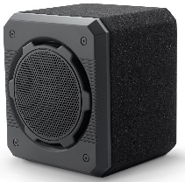
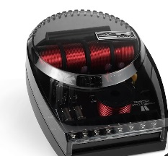
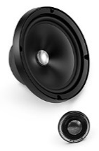
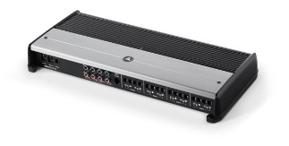
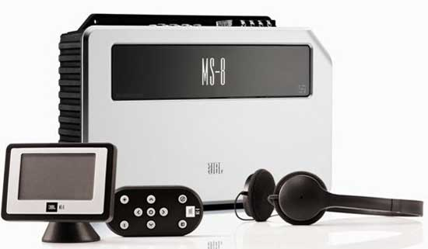
JL Audio CS110G-W6v3: Single 10W6v3 ProWedge
JL Audio ZR650-CSi: 6.5-inch 2-Way Component Speaker System
AMP – BRIDGED CHANNELS 5 & 6
MS-8 CHANNEL 8 (SUB)
JL Audio XD800/8v2
Bridged @ 4Ω = 200 W RMS x 4
AMP - BRIDGED CHANNELS 7 & 8
MS-8 CHANNEL 4 (RR DOOR = RS)
AMP - BRIDGED CHANNELS 5 & 6
MS-8 CHANNEL 3 (LR DOOR = LS)
AMP - BRIDGED CHANNELS 3 & 4
MS-8 CHANNEL 2 (RF DOOR = RF)
AMP - BRIDGED CHANNELS 1 & 2
MS-8
CHANNEL 1
MS-8 CHANNEL 1 (LF DOOR = LF)
MS-8
CHANNEL 4
CHANNEL 3
CHANNEL 2

